Light Hike / Run Packing List

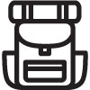 Hiking Gear

- Running pack | - Sunscreen/Lipbalm
- Phone | - Trekking Poles
- Mini First Aid Kit | - Visor
- Mini Multi-Tool | - Appropriate Clothes
- Nutrition | - ID
- Energy Food | - Airpods
- Water | - Sunglasses

